Read line by line
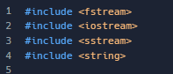
The headers goes first.
<fstream> is for both: Ifstream and Ofstream;
<sstream> for Istringstream
<string> for getline();
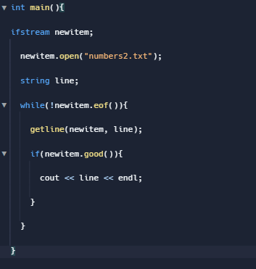

s

We create the “ifstream” variable, where we assign any value we want.

Then we open the file, where it has to exist already, otherwise we’re getting an error. We also can make sure if the file were opened successfully with any condition.

There’s the variable to store the lines.
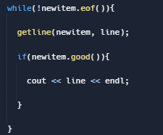
In this while loop, which is negated, otherwise it won’t work, it has to be there, meaning it returns true when it reaches the end of the file (.eof());
The getline function reads the entire line, such thing than both << and >> can’t do. Now the first argument is from where the input the function will work with, and the second, is the variable to store whatever data we need. However, there’s a third argument which leads us to set a limit.
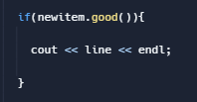

This condition makes sure that we successfully read the line from a file, and then we print it out.

